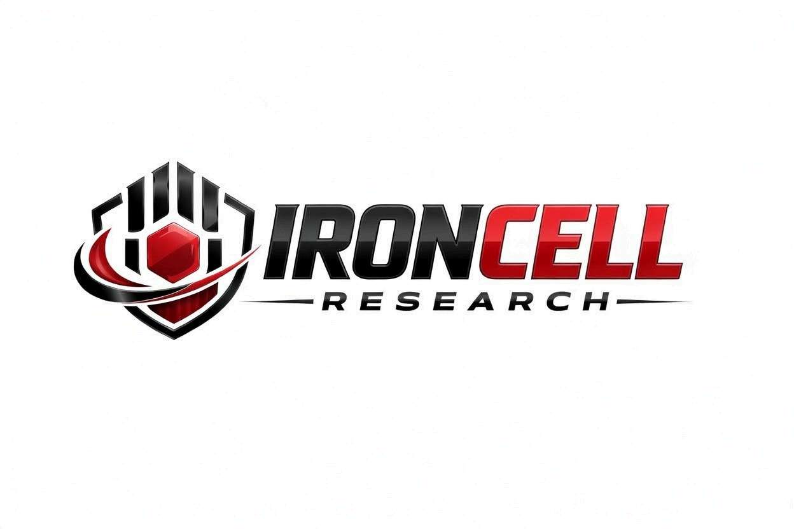
PEPTIDE RESEARCH BRIEF
Semax
Synthetic Heptapeptide | ACTH(4-7) Analog Nootropic Research

Description, Benefits, Dosage & Research Overview

Iron Cell Research
IronCellResearch.com
For Research Use Only


Compound Overview
Compound Name | Semax (ACTH 4-7 PGP)
Classification | Synthetic Heptapeptide / ACTH(4-10) Derivative
Amino Acid Sequence | Met-Glu-His-Phe-Pro-Gly-Pro (7 amino acids)
Molecular Formula | C37H51N9O10S
Molecular Weight | 813.93 g/mol
CAS Number | 80714-61-0
Biological Half-Life | Effects persist for hours despite short plasma half-life
Purity | Greater than or equal to 99%
Storage | Lyophilized, 2-8C, protected from light
Research Status | Approved in Russia (stroke, cognitive disorders); preclinical & clinical research ongoing

Description
Semax is a synthetic heptapeptide derived from the N-terminal fragment (amino acids 4-7) of adrenocorticotropic hormone (ACTH), extended with the C-terminal Pro-Gly-Pro motif to enhance metabolic stability. The sequence (Met-Glu-His-Phe-Pro-Gly-Pro) retains the neurotropic activity of ACTH without engaging the melanocortin-driven corticosteroid axis.
Developed at the Russian Academy of Sciences in the 1980s, Semax was approved in Russia in 2011 for ischemic stroke, optic atrophy, and cognitive disorders. It is studied for nootropic, neuroprotective, and neurotrophic properties, including BDNF and NGF upregulation, dopaminergic and serotonergic modulation, and enkephalin-system effects without dependence or significant side effects.
Semax has gained research interest internationally for applications in cognitive enhancement, ADHD/attention research, stroke neuroprotection, optic-nerve atrophy, and stress-related disorders. For research use only — not for human consumption.

Mechanism of Action

BDNF & NGF Upregulation
Semax rapidly increases BDNF and NGF expression in the hippocampus and cortex within hours of administration. These neurotrophins support neuronal survival, synaptic plasticity, and the formation of long-term memory traces — a core mechanism behind its sustained nootropic effects despite short plasma half-life.

Dopamine & Serotonin Modulation
Semax influences dopamine and serotonin turnover in mesolimbic, frontal cortical, and striatal regions. This modulation contributes to its attention-supporting, motivation, and mood-regulating profile observed across multiple animal models.

Enkephalin System Activation
Semax inhibits enkephalinase enzymes, prolonging the activity of endogenous enkephalins. This contributes to mood elevation, stress buffering, and analgesia in research models — without engaging classical opioid receptors that drive dependence.

Neuroprotective Cascades
In ischemic injury models, Semax reduces neuronal apoptosis, attenuates glutamate excitotoxicity, and dampens neuroinflammation. These effects underpin its approved use in Russia for acute ischemic stroke and chronic cerebrovascular conditions.

Research Benefits

Cognitive & Attention Research
- Working Memory: Research demonstrates improvements in working memory, learning rate, and operant performance in animal and human studies.
- Attention & Focus: Human research shows enhanced sustained attention, processing speed, and reduction in mental fatigue under load.
- BDNF-Driven Plasticity: BDNF upregulation provides a mechanistic basis for durable cognitive effects beyond plasma residence time.
- Mental Endurance: Studied in research settings as an anti-fatigue tool under cognitive load and sleep deprivation.

Stroke & Neuroprotection
- Ischemic Stroke: Approved in Russia for acute ischemic stroke; research shows reduced neurological deficit when administered in the acute window.
- Neuronal Survival: In preclinical models, Semax reduces apoptosis in penumbral tissue and supports recovery of motor and cognitive function.
- Brain Energy Metabolism: Modulates antioxidant defense and supports mitochondrial function in stressed neural tissue.

Optic Atrophy & Vision Research
- Optic Neuroprotection: Approved in Russia for optic nerve atrophy and used in glaucoma research due to retinal/optic ganglion cell neurotrophic effects.
- Retinal Function: Studies suggest preservation of visual function and contrast sensitivity in degenerative retinal models.
- Visual Acuity: Russian clinical use includes long-term optic neuropathy regimens with positive functional outcomes.

Stress & Mood Research
- Stress Resilience: Animal models show reduced anxiety-like behavior under acute stress without sedation.
- Mood Support: Mood-elevating effects mediated by dopamine, serotonin, and enkephalin modulation.
- Cognitive Healthspan: Studied as a preventive nootropic in aging-related cognitive decline research.

Clinical & Research Status
- Approved Use: Approved by the Russian Ministry of Health for ischemic stroke, optic atrophy, and cognitive disorders.
- Outside Russia: Available globally as a research compound; not approved by the FDA.
- Research Applications: Widely studied for cognitive enhancement, neuroprotection, and stress-disorder research worldwide.

Dosage & Administration
The following dosage information is provided for research reference purposes only. Semax is for laboratory research use only and is not intended for human consumption.
Protocol | Dose Range | Route | Frequency
Russian Clinical Dose | 600-900 mcg | Intranasal / SubQ | Once or twice daily
Research Low | 300 mcg | Intranasal / SubQ | Once or twice daily
Research Standard | 600-900 mcg | Intranasal / SubQ | Once or twice daily
Cycling Protocol | 600-900 mcg daily x 3-6 months | Intranasal / SubQ | Then break for 1-2 weeks

Reconstitution Guidelines
Solvent | Sterile bacteriostatic water
Reconstitution | 2 mL BAC water per 10mg vial (5 mg/mL)
Mixing | Gently swirl until dissolved; do not shake
Storage | Refrigerate at 2-8C, use within 21 days
Injection Site | Intranasal drops most common in Russian protocols; subQ also used in research
Timing | Morning dosing preferred; second dose mid-day for extended cognitive demand

Safety Profile
Semax has an established clinical safety profile from over a decade of Russian clinical use:
- General Tolerability: Excellent tolerability profile across long-term clinical use; no dependence or tolerance reported.
- Injection Site Reactions: Mild transient irritation possible with intranasal or subcutaneous administration.
- Arthralgia & Myalgia: Not characteristic of Semax in clinical trials.
- Peripheral Edema: Not characteristic of Semax.
- Glucose Metabolism: No clinically significant effects on glucose metabolism reported.
- IGF-1 Monitoring: No routine endocrine monitoring required in published research protocols.
- Contraindications: Known hypersensitivity to the compound. Limited safety data in pregnancy and lactation.

Key References
- Ashmarin IP, Nezavibatko VN, et al. Nootropic Analogue of ACTH(4-10) — Semax: 15 Years Experience in Design and Investigation. Zh Vyssh Nerv Deiat. 1997;47(2):420-430.
- Dolotov OV, et al. Semax Increases BDNF Levels in the Rat Brain. Doklady Biological Sciences. 2003;391:292-295.
- Gusev EI, Skvortsova VI, et al. Neuroprotective Effects of Semax in Acute Ischemic Stroke. Stroke. 2005;36(6):1166-1172.
- Inozemtseva LS, et al. Semax Increases Expression of BDNF and Trophic Factors in Hippocampus. Brain Research. 2008;1219:32-38.
- Sebentsova EA, et al. Effects of Semax on the Behavior and BDNF Levels in the Rat Hippocampus. Bulletin of Experimental Biology and Medicine. 2010;149(1):54-58.
- Levitskaya NG, et al. Effects of Semax on Cognitive Functions in Rats. Neuroscience and Behavioral Physiology. 2002;32(3):261-265.
- Medvedeva EV, et al. The Peptide Semax Affects the Expression of Genes Involved in Inflammatory Response. Frontiers in Pharmacology. 2017;8:609.

Contact & Information
Company | Iron Cell Research
Website | IronCellResearch.com
Email | orders@ironcellresearch.com
Product Support | Available via website contact form

Disclaimer
This document is intended for informational and research purposes only. Semax is sold as a research compound and is not intended for human consumption. The information provided herein does not constitute medical advice, diagnosis, or treatment recommendations. All research applications should comply with applicable institutional, local, and federal regulations. Iron Cell Research makes no claims regarding the therapeutic efficacy of Semax for any medical condition. Researchers should consult with qualified healthcare professionals and institutional review boards before initiating any research protocols involving human subjects.
Iron Cell Research - For Research Use Only


